Thread concepts:

----------------

Start() executes run method. it implements concurrency. But if you do like thread. Run()..it just start normal run method...not does like thread.

periority - by setting periority to threads, we can give more changes to that thread. But it is just request.

t1.join()- it means after t1 completion only, other task will be started.

## Java Inter Thread Communication Example using wait() and notify() methods

[](https://3.bp.blogspot.com/-K6q0DQ1v-tw/TWu8owBtc2I/AAAAAAAAADA/oBoHDBiJ8ag/s1600/17.jpg)We have a shared Queue and [two threads](http://javarevisited.blogspot.sg/2013/02/how-to-join-multiple-threads-in-java-example-tutorial.html) called Producer and Consumer. Producer thread puts numbers into a shared queue and Consumer thread consumes numbers from the shared buckets.  
  
 Condition is that once an item is produced, the consumer thread must be notified, and similarly after consumption producer thread needs to be notified. This inter-thread communication is achieved using the wait and notify method. Remember [wait and notify method is defined in the object class](http://javarevisited.blogspot.in/2012/02/why-wait-notify-and-notifyall-is.html), and they are must be called inside the synchronized block.

**package** concurrency;

**import** **java.util.LinkedList**;

**import** **java.util.Queue**;

**import** **org.apache.log4j.Logger**;

**public** **class** **InterThreadCommunicationExample** {

**public** **static** **void** **main**(String args[]) {

**final** Queue sharedQ = **new** LinkedList();

        Thread producer = **new** Producer(sharedQ);

        Thread consumer = **new** Consumer(sharedQ);

        producer.start();

        consumer.start();

    }

}

**public** **class** **Producer** **extends** Thread {

**private** **static** **final** Logger logger = Logger.getLogger(Producer.class);

**private** **final** Queue sharedQ;

**public** **Producer**(Queue sharedQ) {

**super**("Producer");

**this**.sharedQ = sharedQ;

    }

    @Override

**public** **void** **run**() {

**for** (**int** i = **0**; i < **4**; i++) {

**synchronized** (sharedQ) {

                //waiting condition - wait until Queue is not empty

**while** (sharedQ.size() >= **1**) {

**try** {

                        logger.debug("Queue is full, waiting");

                        sharedQ.wait();

                    } **catch** (InterruptedException ex) {

                        ex.printStackTrace();

                    }

                }

                logger.debug("producing : " + i);

                sharedQ.add(i);

                sharedQ.notify();

            }

        }

    }

}

**public** **class** **Consumer** **extends** Thread {

**private** **static** **final** Logger logger = Logger.getLogger(Consumer.class);

**private** **final** Queue sharedQ;

**public** **Consumer**(Queue sharedQ) {

**super**("Consumer");

**this**.sharedQ = sharedQ;

    }

    @Override

**public** **void** **run**() {

**while**(**true**) {

**synchronized** (sharedQ) {

                //waiting condition - wait until Queue is not empty

**while** (sharedQ.size() == **0**) {

**try** {

                        logger.debug("Queue is empty, waiting");

                        sharedQ.wait();

                    } **catch** (InterruptedException ex) {

                        ex.printStackTrace();

                    }

                }

**int** number = sharedQ.poll();

                logger.debug("consuming : " + number );

                sharedQ.notify();

                //termination condition

**if**(number == **3**){**break**; }

            }

        }

    }

}

*Output:*

**05**:**41**:**57**,**244** **0**    [Producer] DEBUG concurrency.Producer  - producing : **0**

**05**:**41**:**57**,**260** **16**   [Producer] DEBUG concurrency.Producer  - Queue is full, waiting

**05**:**41**:**57**,**260** **16**   [Consumer] DEBUG concurrency.Consumer  - consuming : **0**

**05**:**41**:**57**,**260** **16**   [Consumer] DEBUG concurrency.Consumer  - Queue is empty, waiting

**05**:**41**:**57**,**260** **16**   [Producer] DEBUG concurrency.Producer  - producing : **1**

**05**:**41**:**57**,**260** **16**   [Producer] DEBUG concurrency.Producer  - Queue is full, waiting

**05**:**41**:**57**,**260** **16**   [Consumer] DEBUG concurrency.Consumer  - consuming : **1**

**05**:**41**:**57**,**260** **16**   [Consumer] DEBUG concurrency.Consumer  - Queue is empty, waiting

**05**:**41**:**57**,**260** **16**   [Producer] DEBUG concurrency.Producer  - producing : **2**

**05**:**41**:**57**,**260** **16**   [Producer] DEBUG concurrency.Producer  - Queue is full, waiting

**05**:**41**:**57**,**260** **16**   [Consumer] DEBUG concurrency.Consumer  - consuming : **2**

**05**:**41**:**57**,**260** **16**   [Consumer] DEBUG concurrency.Consumer  - Queue is empty, waiting

**05**:**41**:**57**,**260** **16**   [Producer] DEBUG concurrency.Producer  - producing : **3**

**05**:**41**:**57**,**276** **32**   [Consumer] DEBUG concurrency.Consumer  - consuming : **3**

| Wait() | Sleep() |
| --- | --- |
| Wait() method belongs to Object class. | Sleep() method belongs to Thread class. |
| Wait() method releases lock during Synchronization. | Sleep() method does not release the lock on object during Synchronization. |
| Wait() should be called only from Synchronized context. | There is no need to call sleep() from Synchronized context. |
| Wait() is not a static method. | Sleep() is a static method. |
| Wait() Has Three Overloaded Methods:   * wait() * wait(long timeout) * wait(long timeout, int nanos) | Sleep() Has Two Overloaded Methods:   * sleep(long millis)millis: milliseconds * sleep(long millis,int nanos) nanos: Nanoseconds |
| public final void wait(long timeout) | public static void sleep(long millis) throws Interrupted_Execption |

**Example For Sleep Method:**

synchronized(monitor)

{

Thread.sleep(1000); Here Lock Is Held By The Current Thread

//after 1000 milliseconds, current thread will wake up, or after we call that is interrupt() method

}

**Example For wait Method:**

synchronized(monitor)

{

monitor.wait() Here Lock Is Released By Current Thread

}

**yield() Method**

* If any thread executes the yield method, the thread scheduler checks if there is any thread with the same or high priority as this thread. If the processor finds any thread with higher or same priority then it will move the current thread to Ready/Runnable state and give the processor to another thread and if not – the current thread will keep executing.

Volatile variable:

Volatile variable is stored in shared cache, not local cache. If we use this with synchronization, threads can read or write value without any mistake.

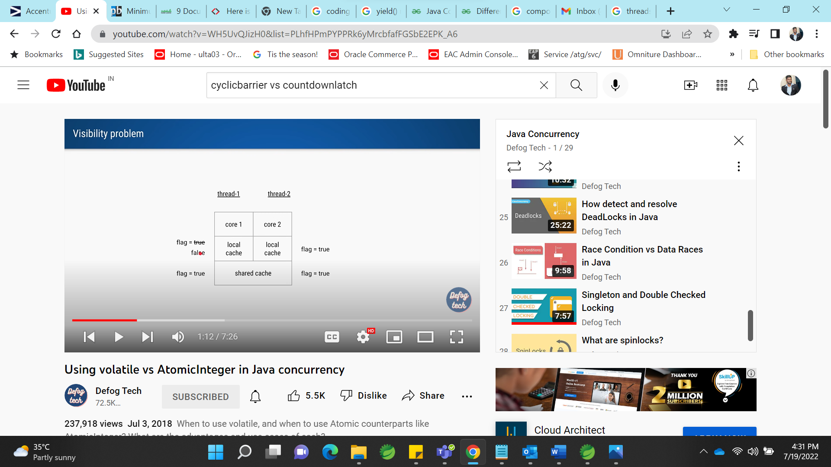

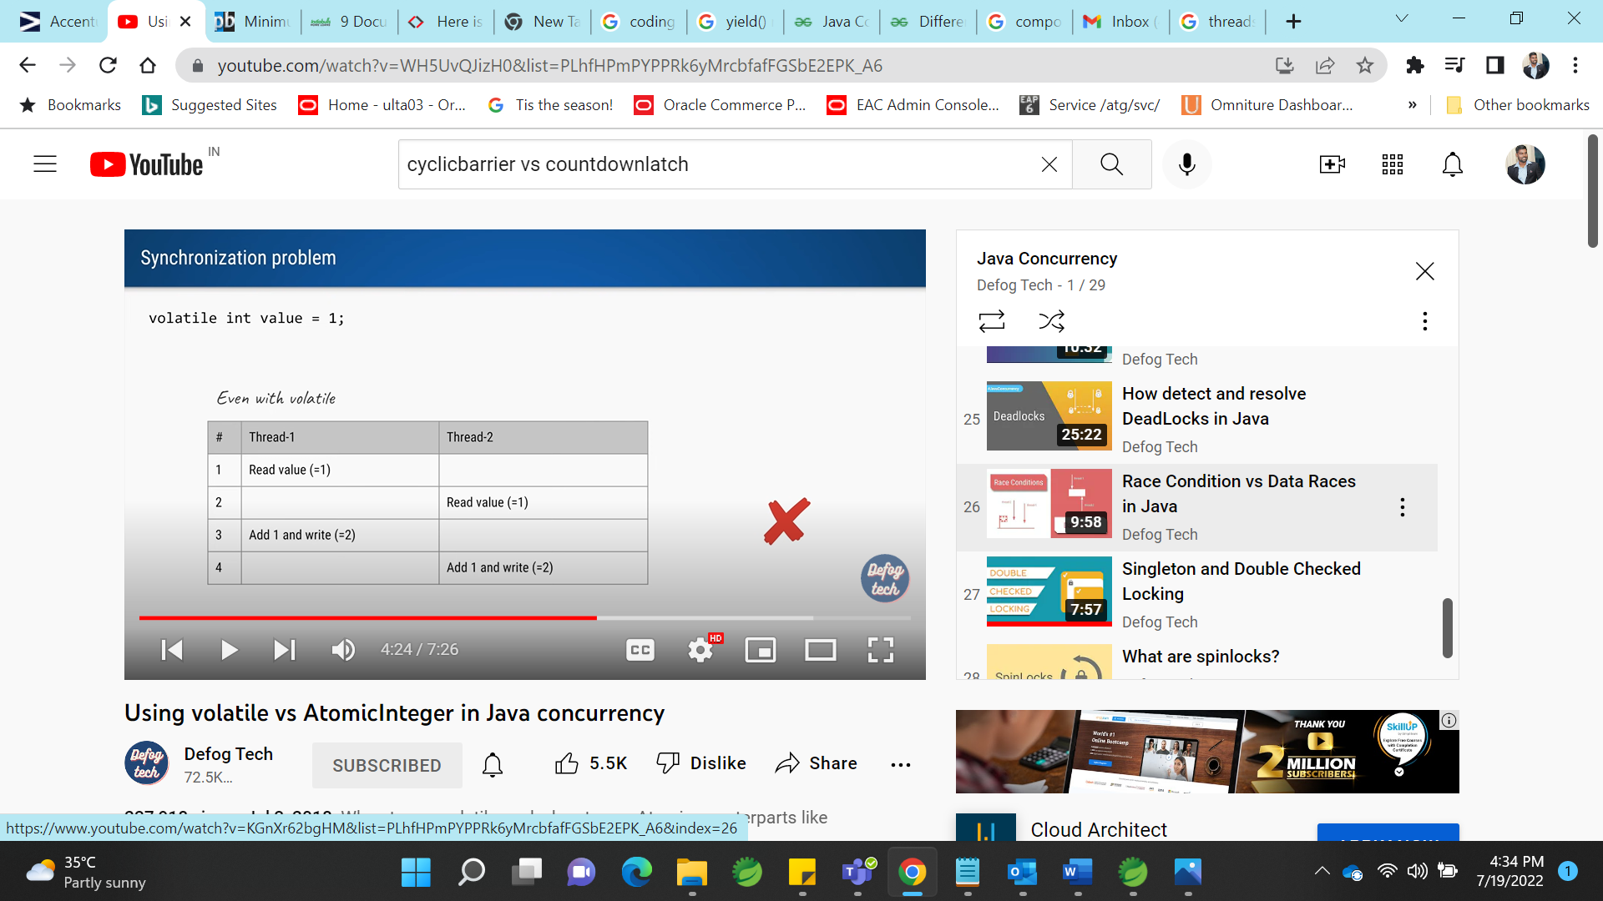

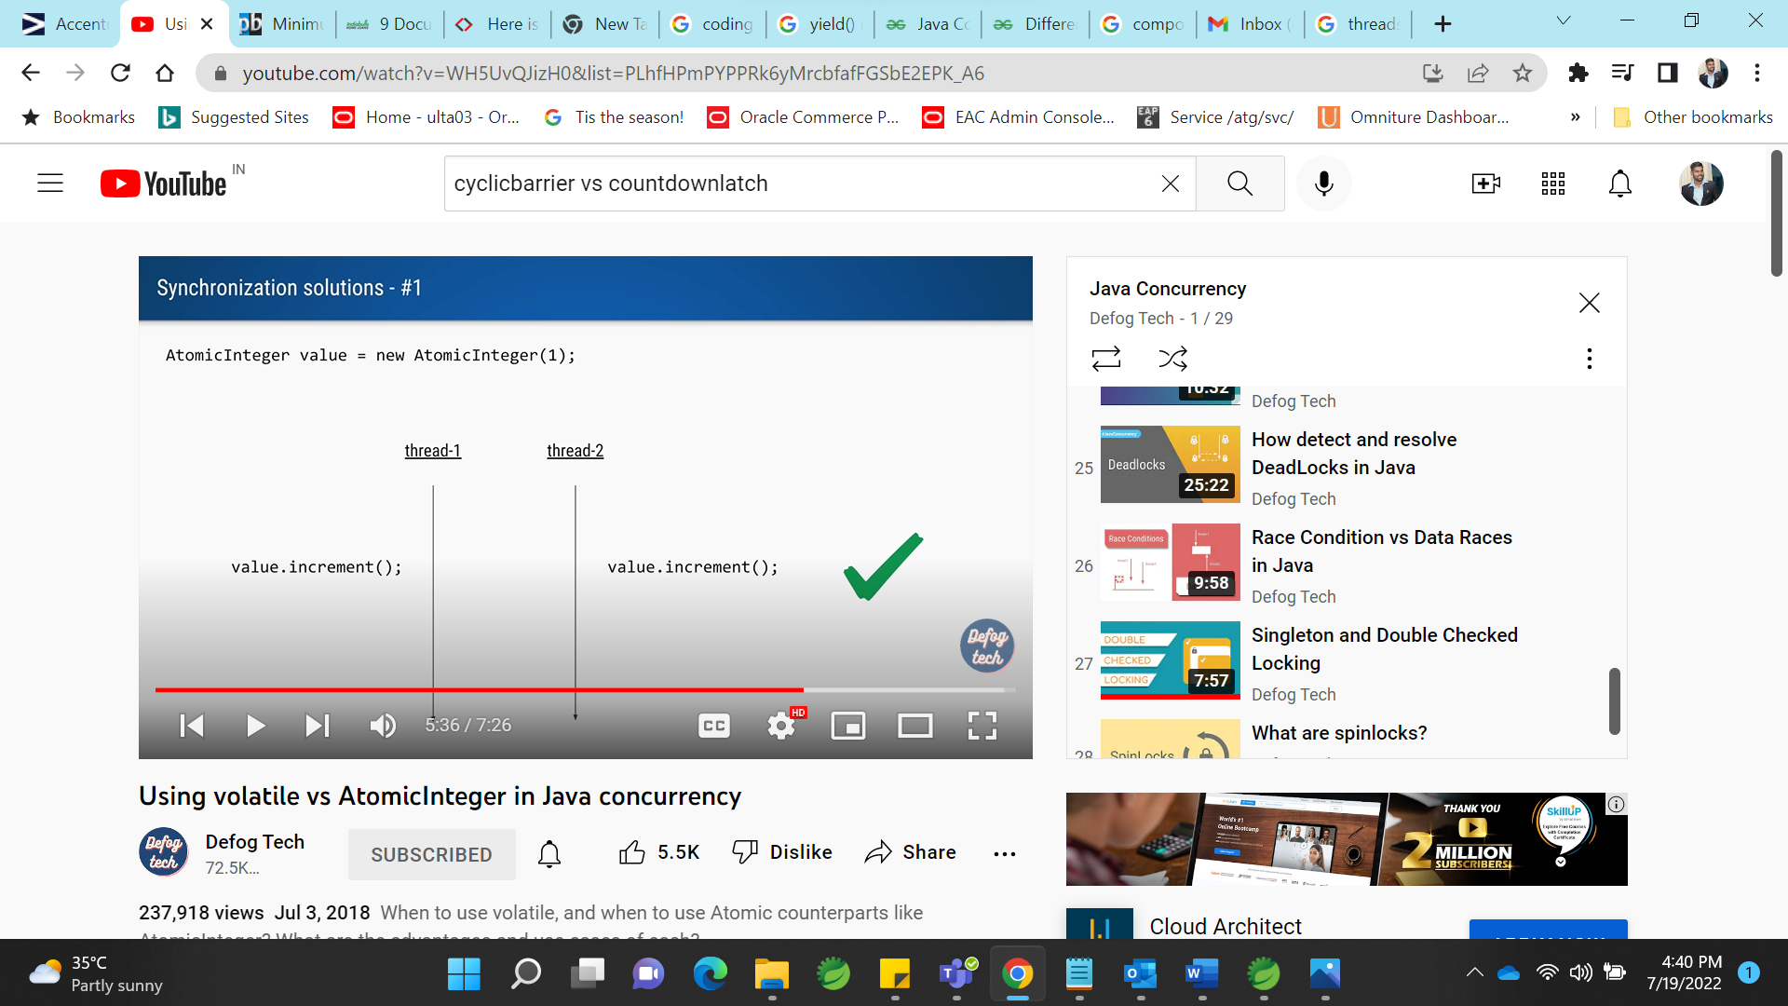

For atomic variables, read and write is done at same time without synchronization. 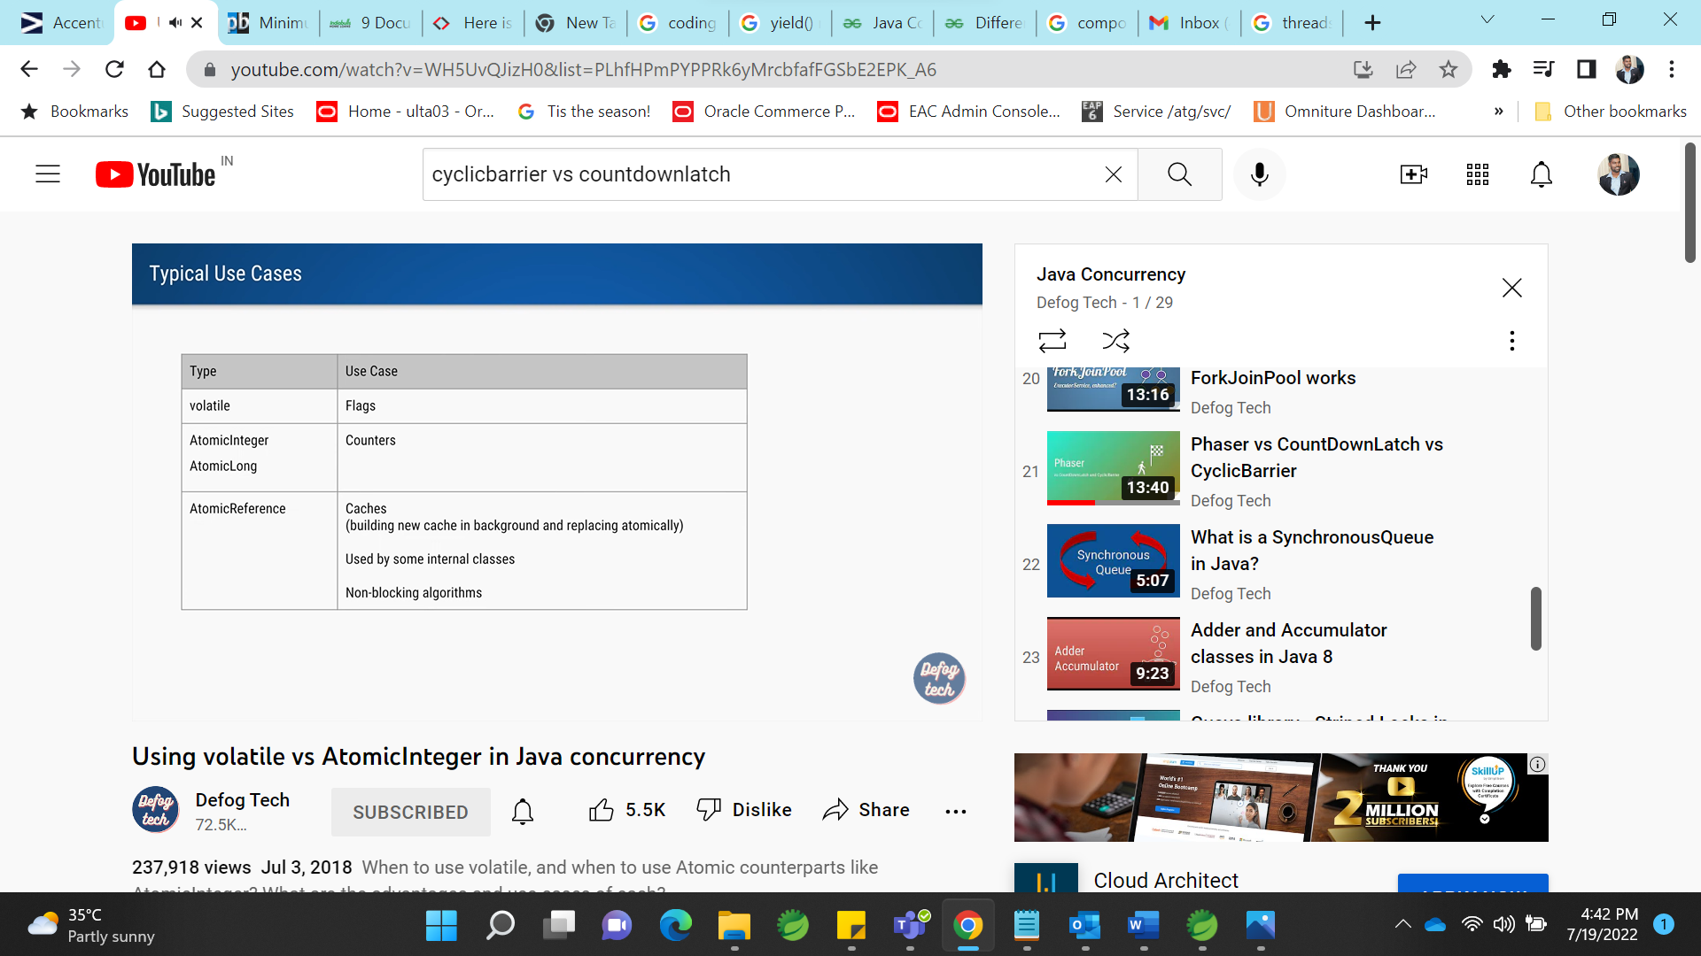

**Join** : t1.join means after completion of t1 only, others threads are executed.

**ExecutorService** is a JDK API that **simplifies running tasks in asynchronous mode**. Generally speaking, ExecutorService automatically provides a pool of threads and an API for assigning tasks to it.

This is very important question to start your interview with. [Executor and ExecutorService](http://www.javamadesoeasy.com/2015/03/executor-and-executorservice-framework.html) are used for  following purposes >

* creating thread in java,
* starting threads in java,
* managing whole [life cycle of Threads](http://www.javamadesoeasy.com/2015/03/thread-states-thread-life-cycle-in-java.html) in java.

Executor creates [pool of threads](http://www.javamadesoeasy.com/2015/03/implement-thread-pool-in-java.html) and manages life cycle of all threads in it.

In Executor framework, **Executor** interface and  **ExecutorService**  class are most prominently used in java.

**Executor Service : it reduces boiler plate code**

**Single Thread:**

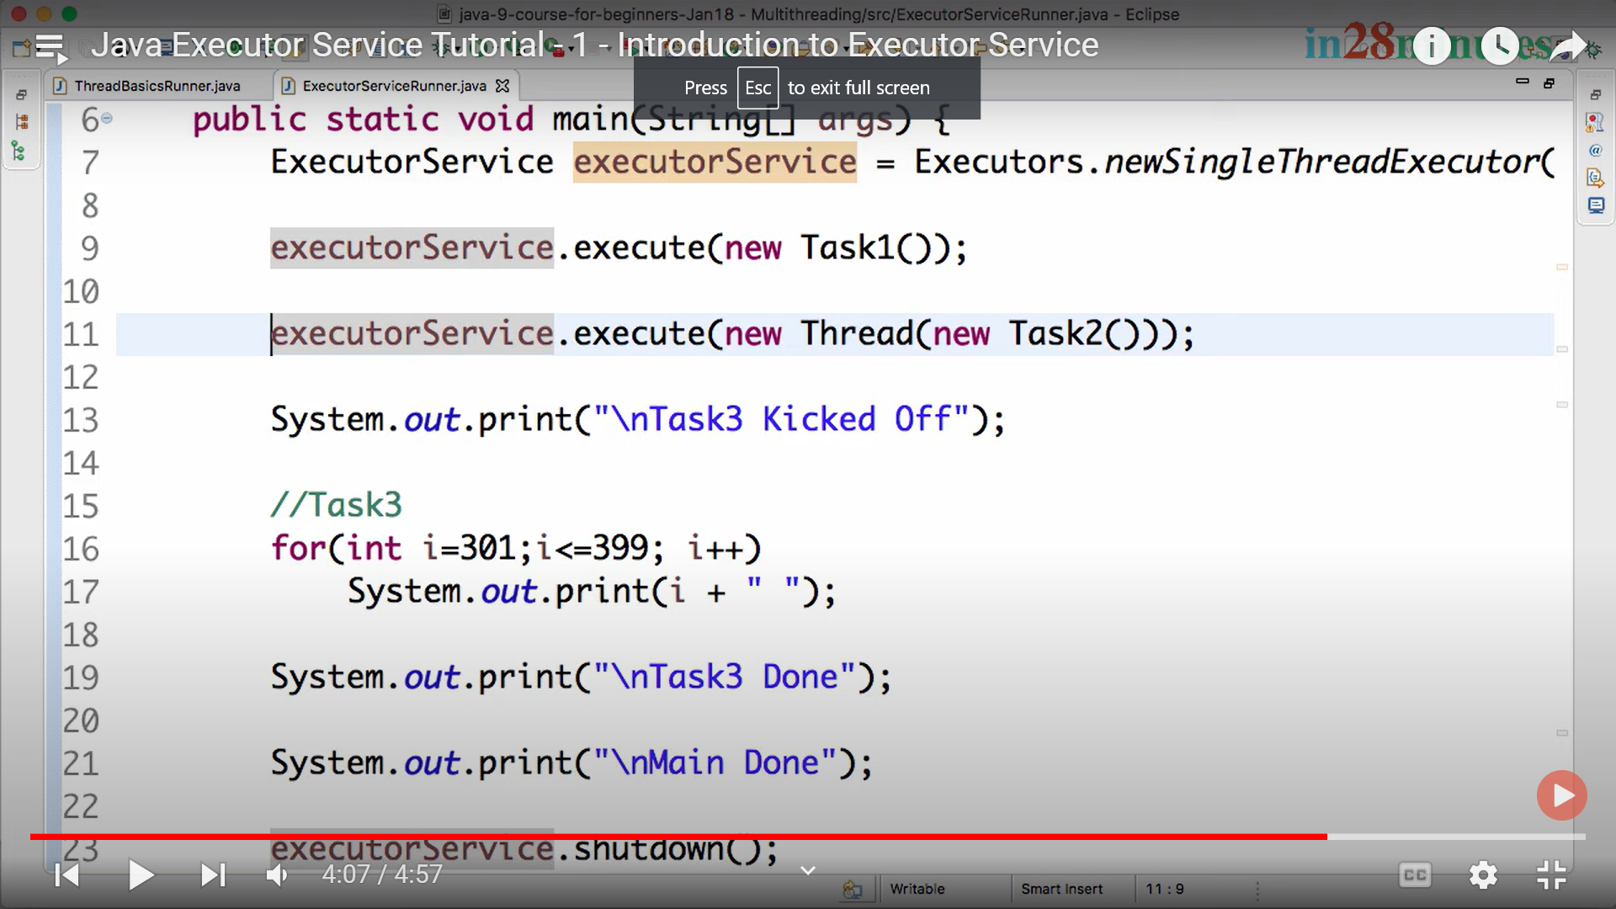

**Fixed size thread pool:**

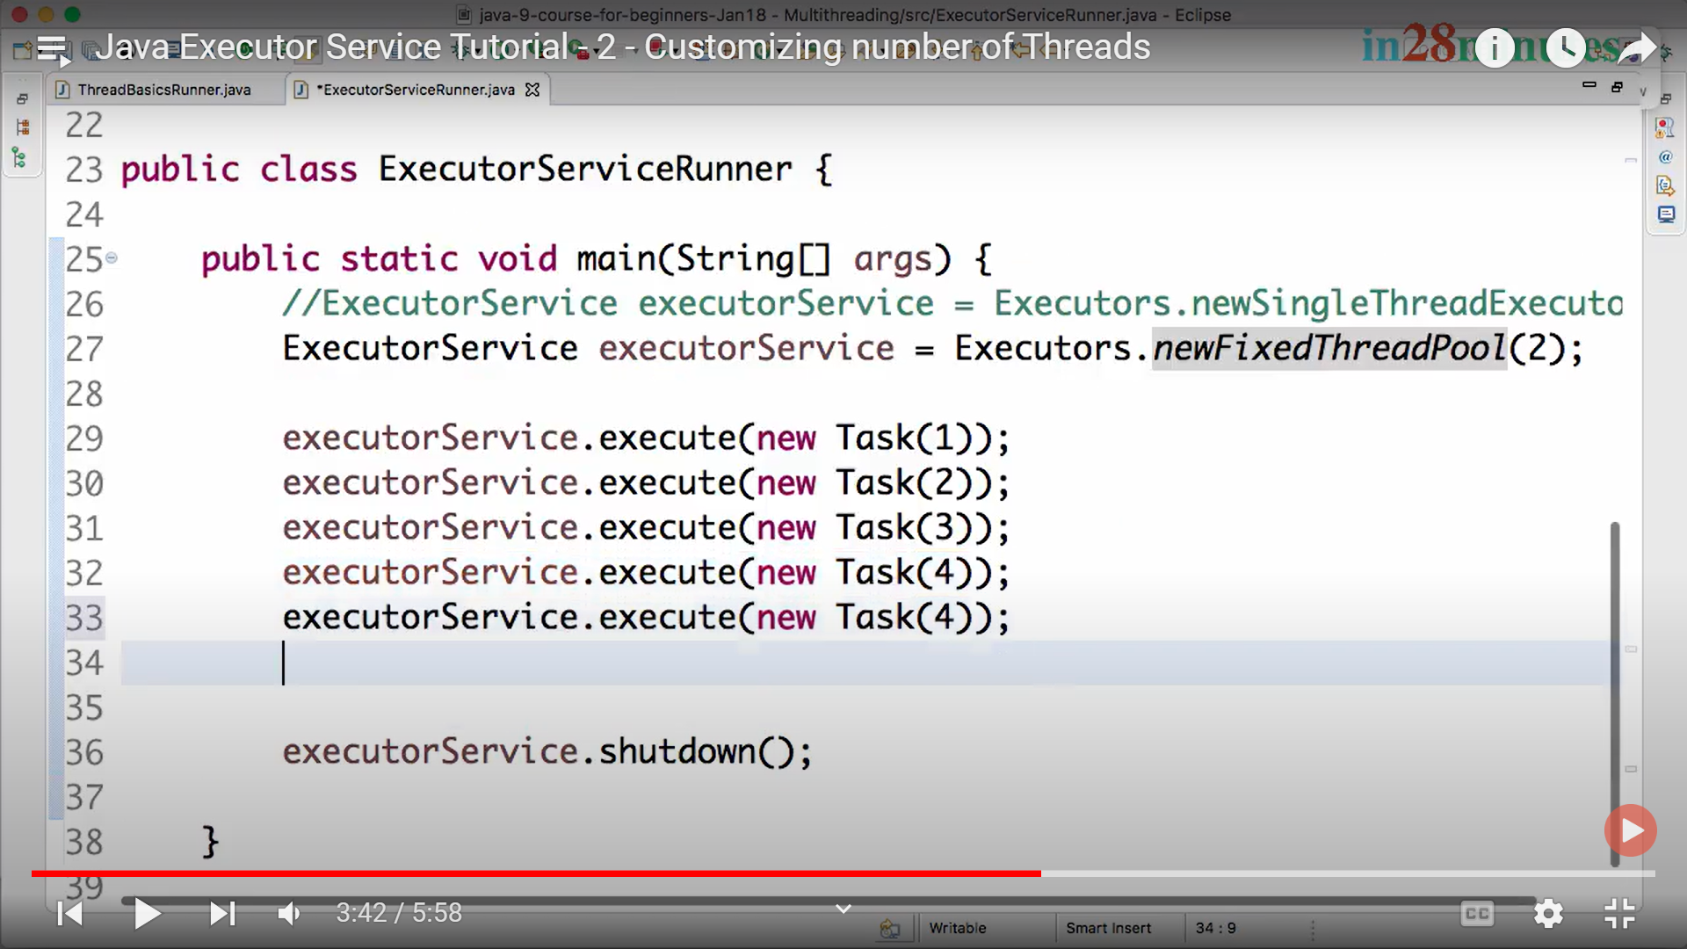

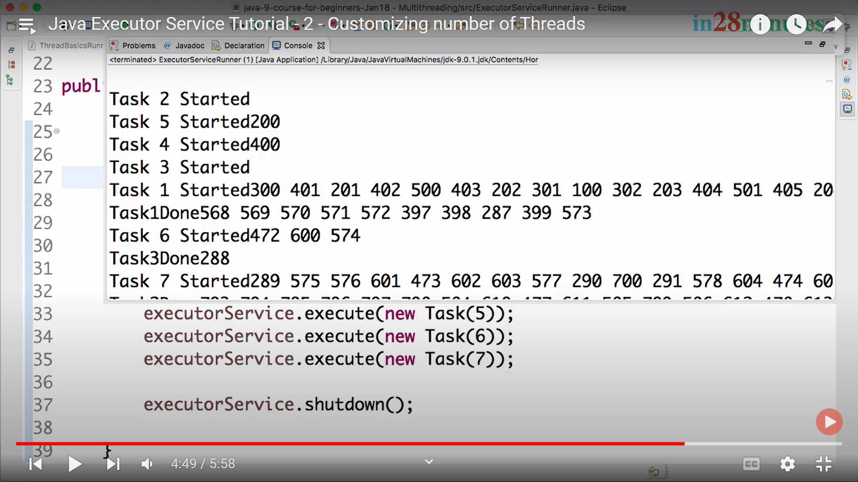

**ThreadLocal:**

**2 thread creating 2 simpleformate instance 2 times**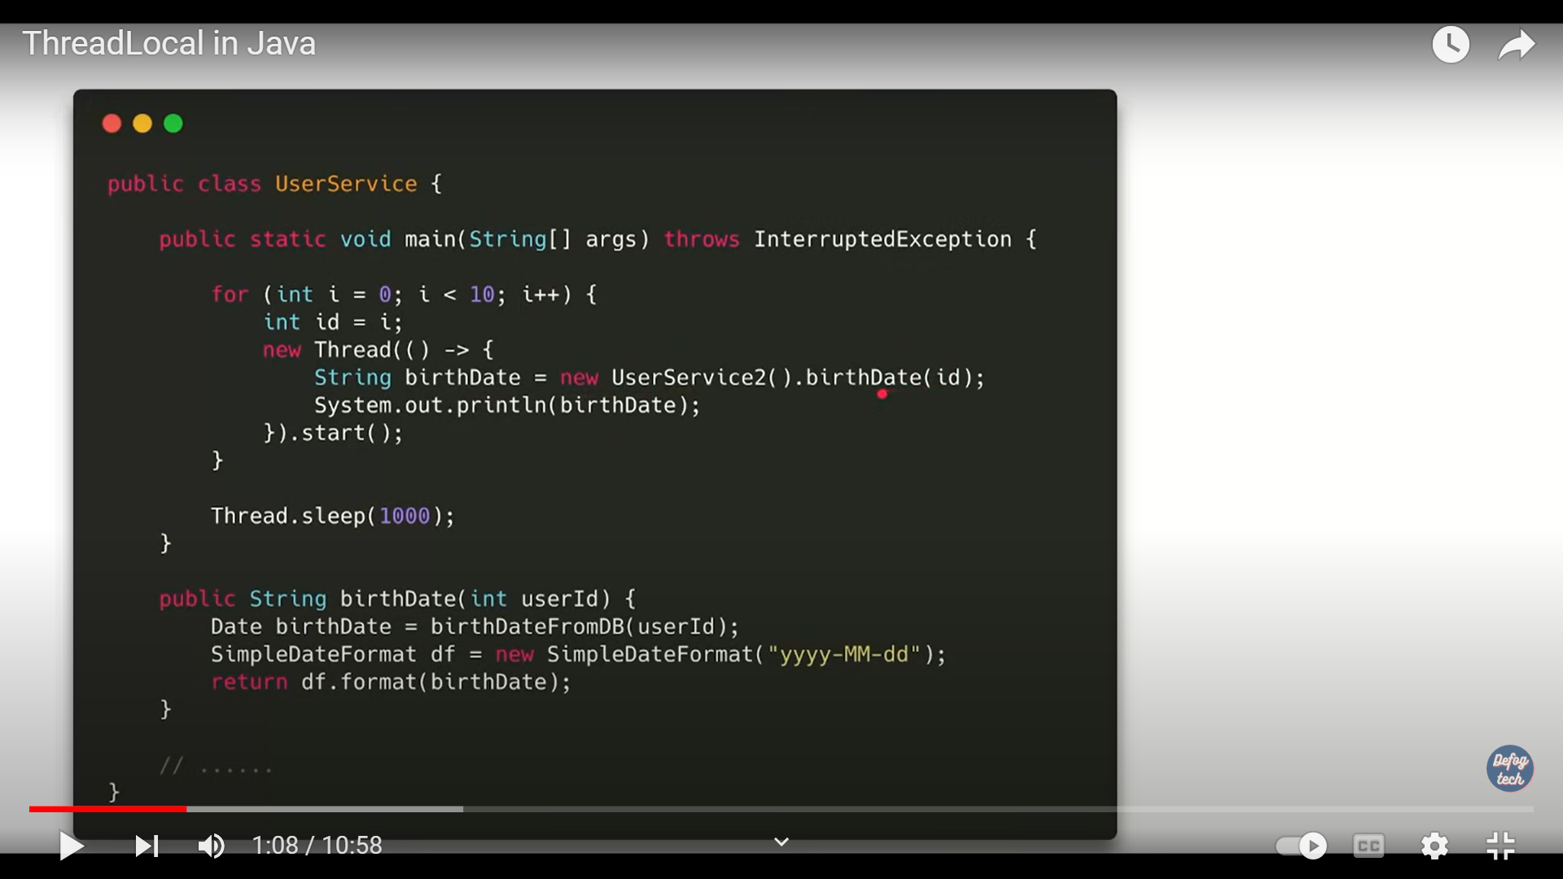

**10 thread creating 10 simpleformate instance 10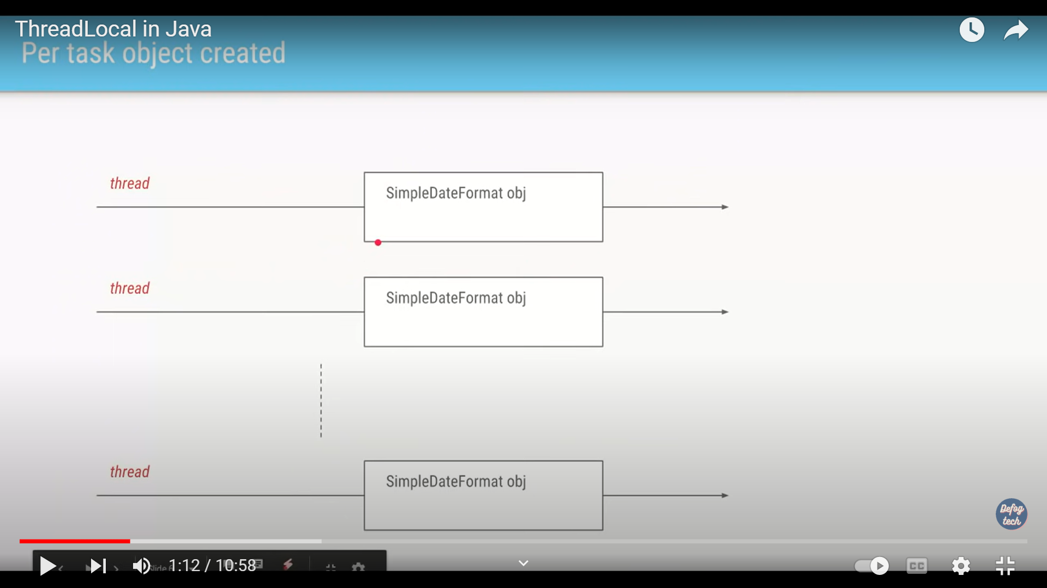 times**

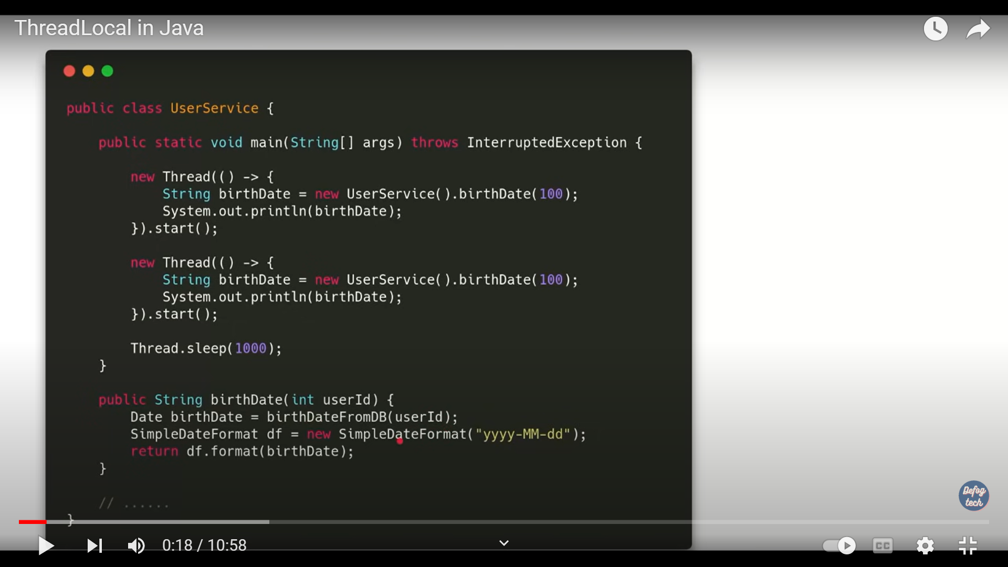

If we want to run 1000 task, we should not create 1000 threads, that will create lot of memory.

To avoid it, we just create thread pool with some amount of thread.

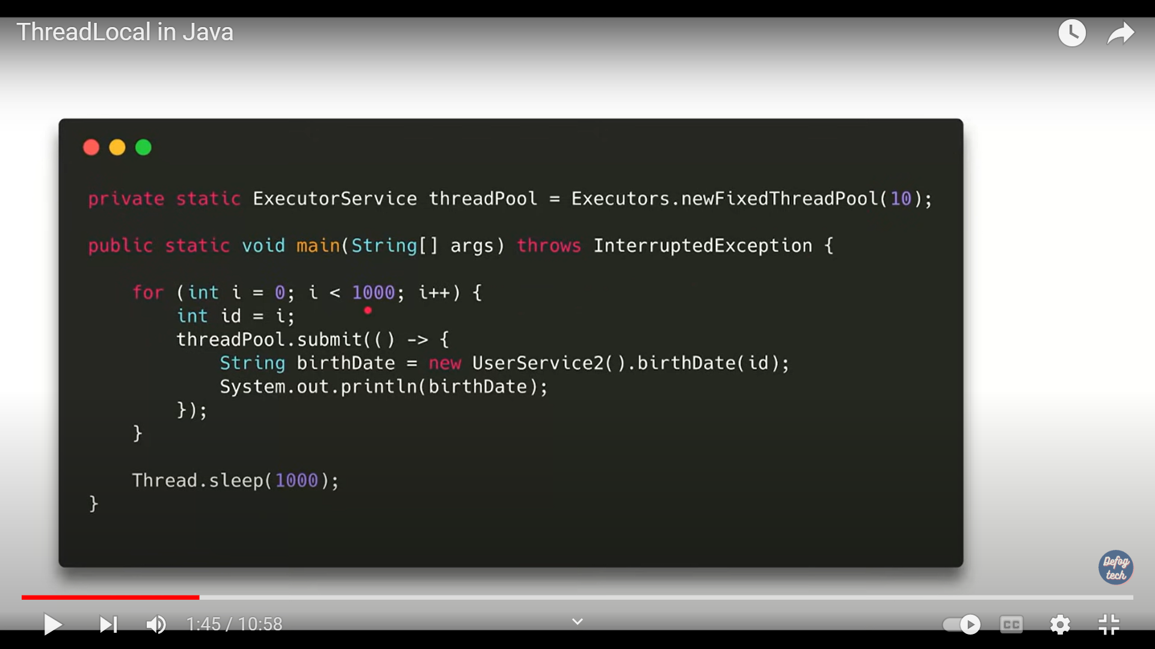

Here 10 threads runs 1000 threads concurrently.

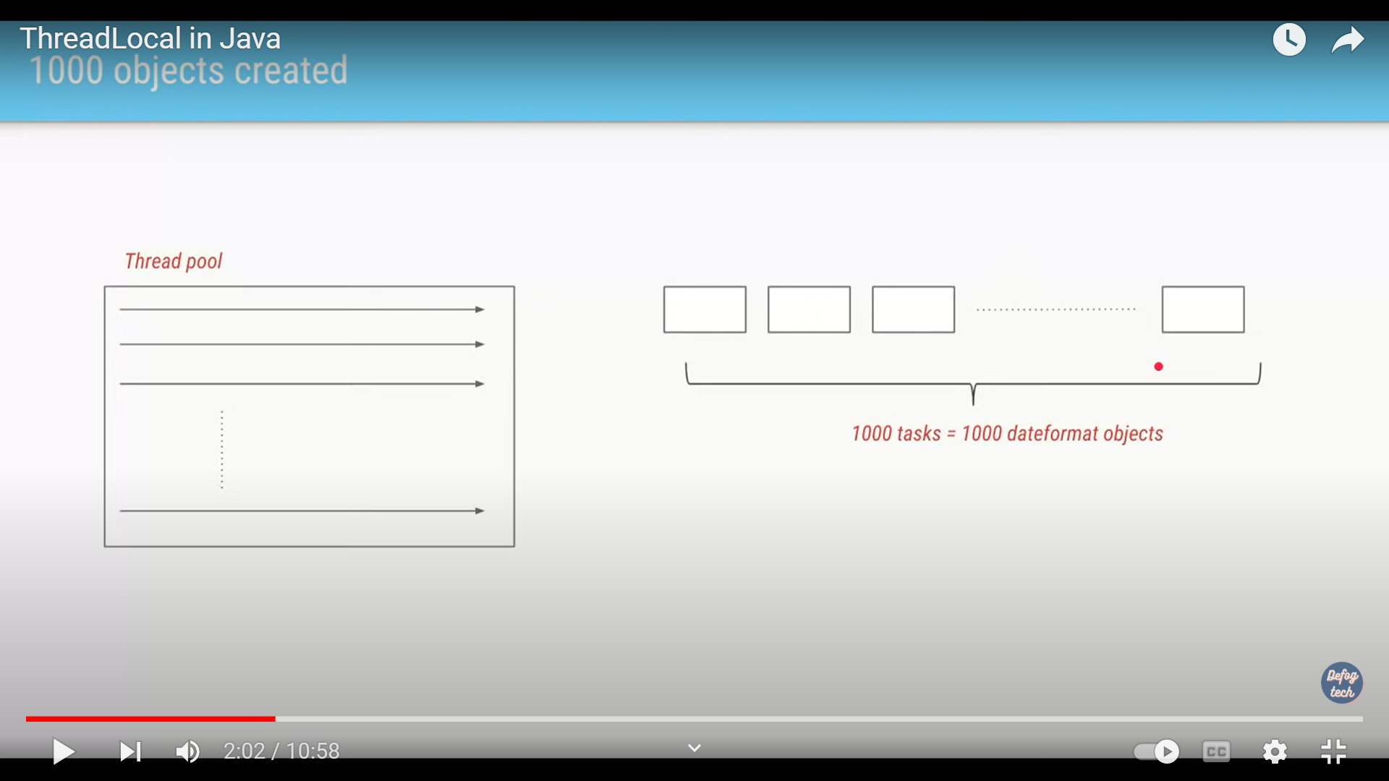

But 1000 instance created. To inefficiency.

To resolve it

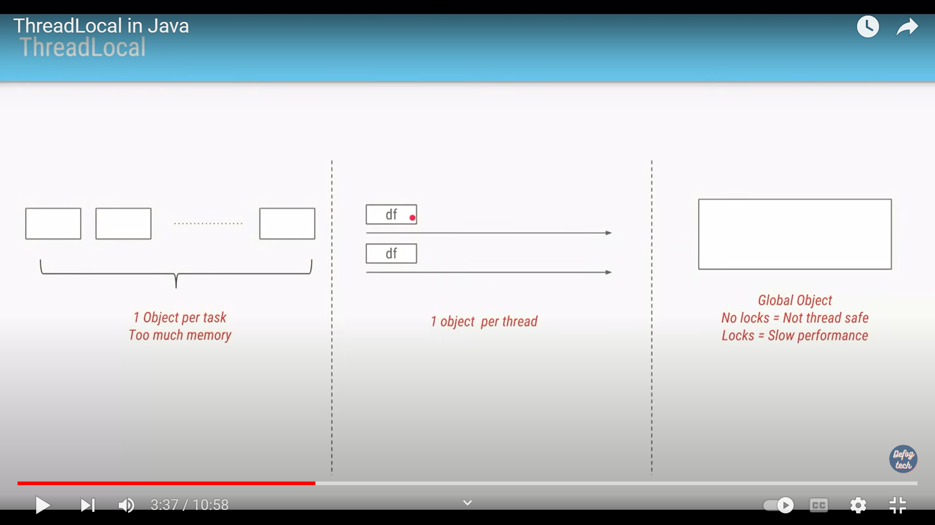

One object for one thread.. here for 10 thread, 10 object instead of creating each task.

We need to use threadlocal. 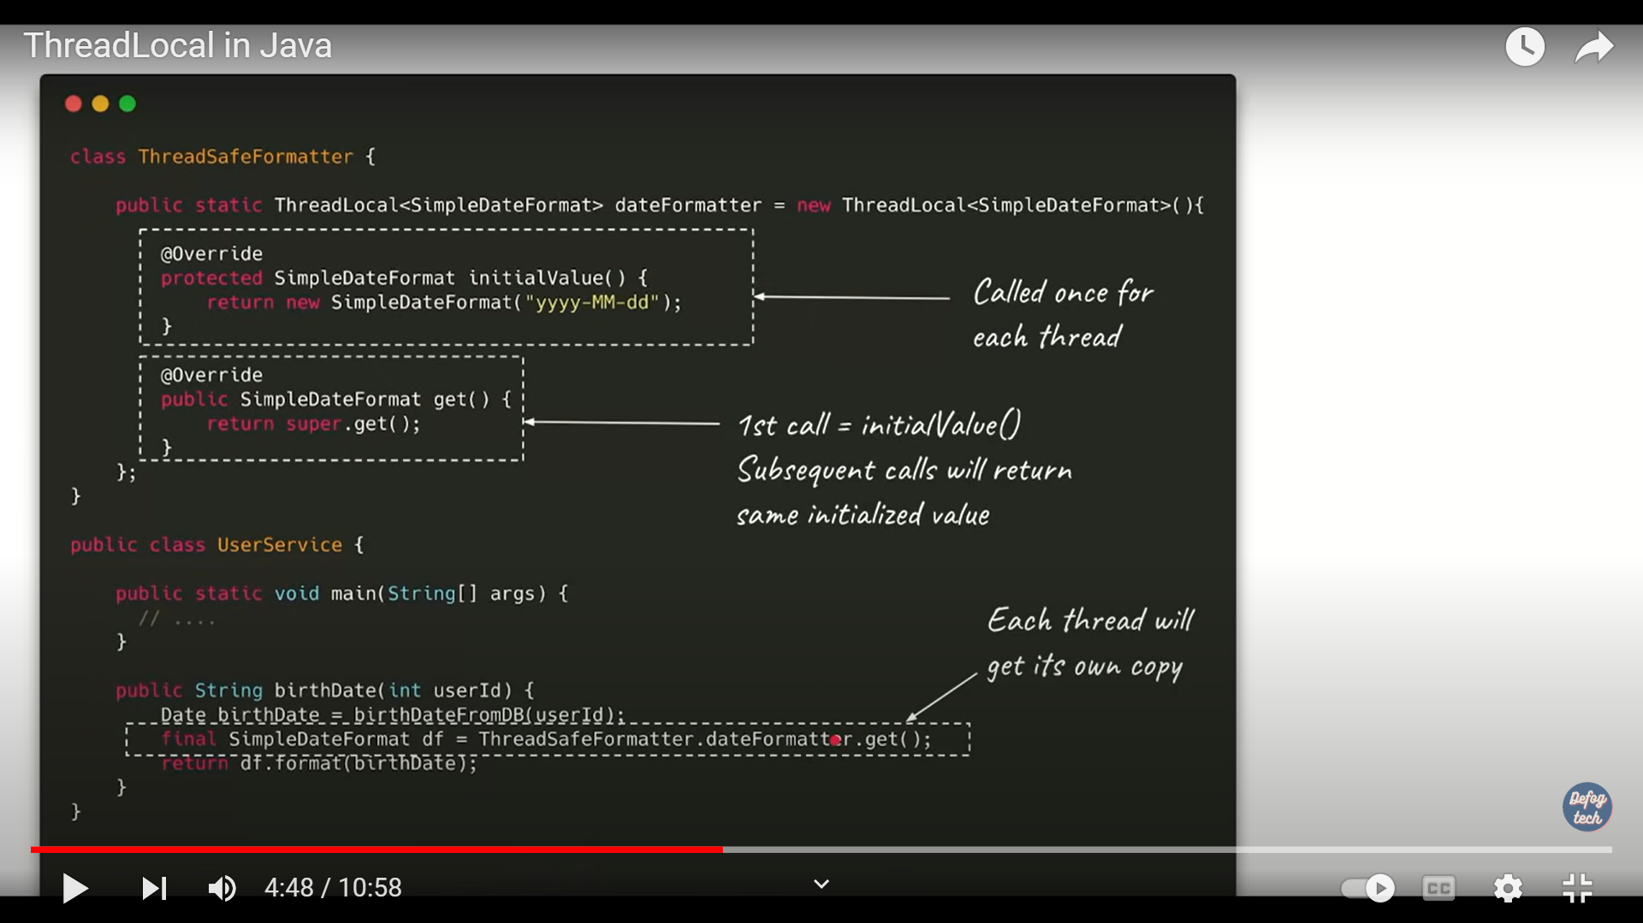

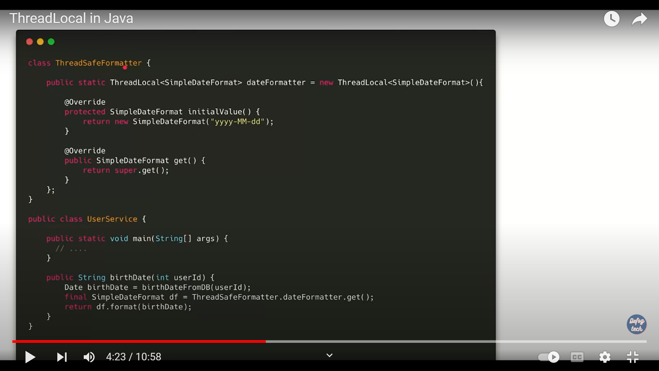

Basic Lock function: one thread can acquire one lock at time. Remaining thread is in waiting status. Once it release the lock. Other thread become runnable status and either of one acquire locks.

The example shows for book my show. 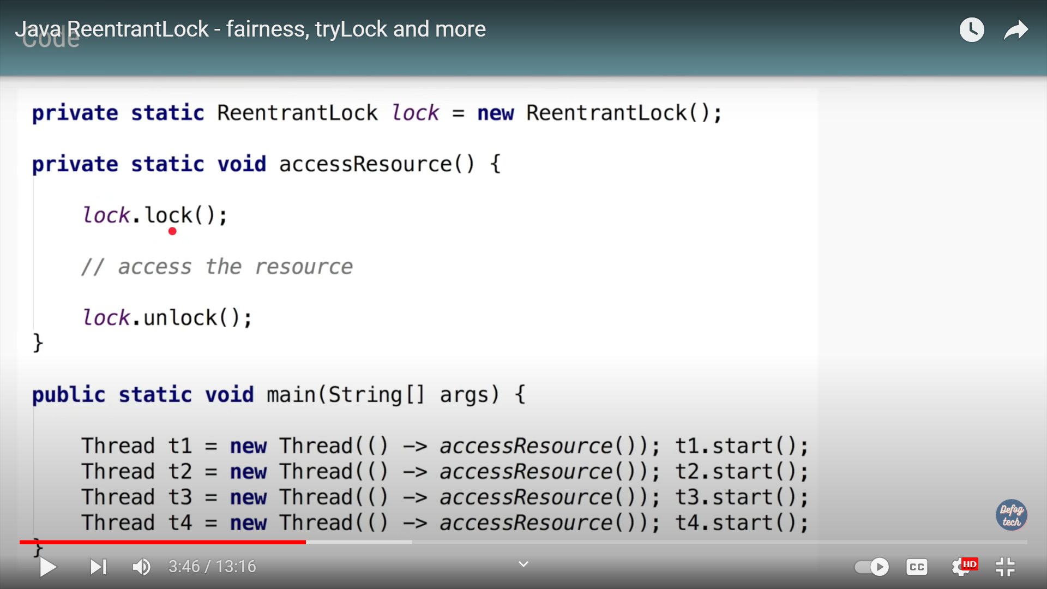

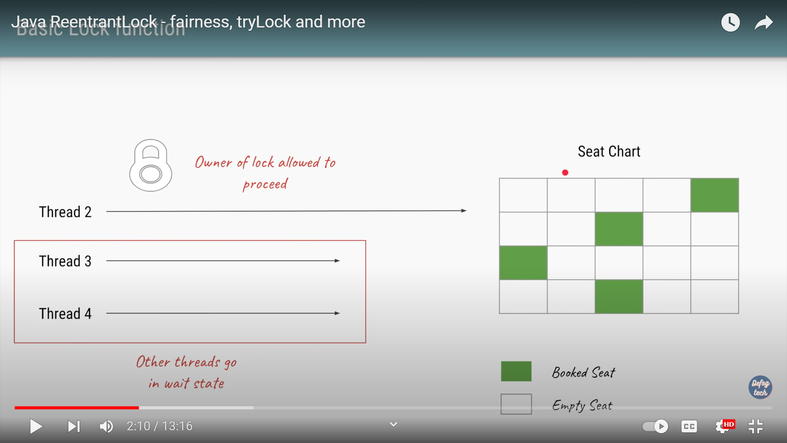

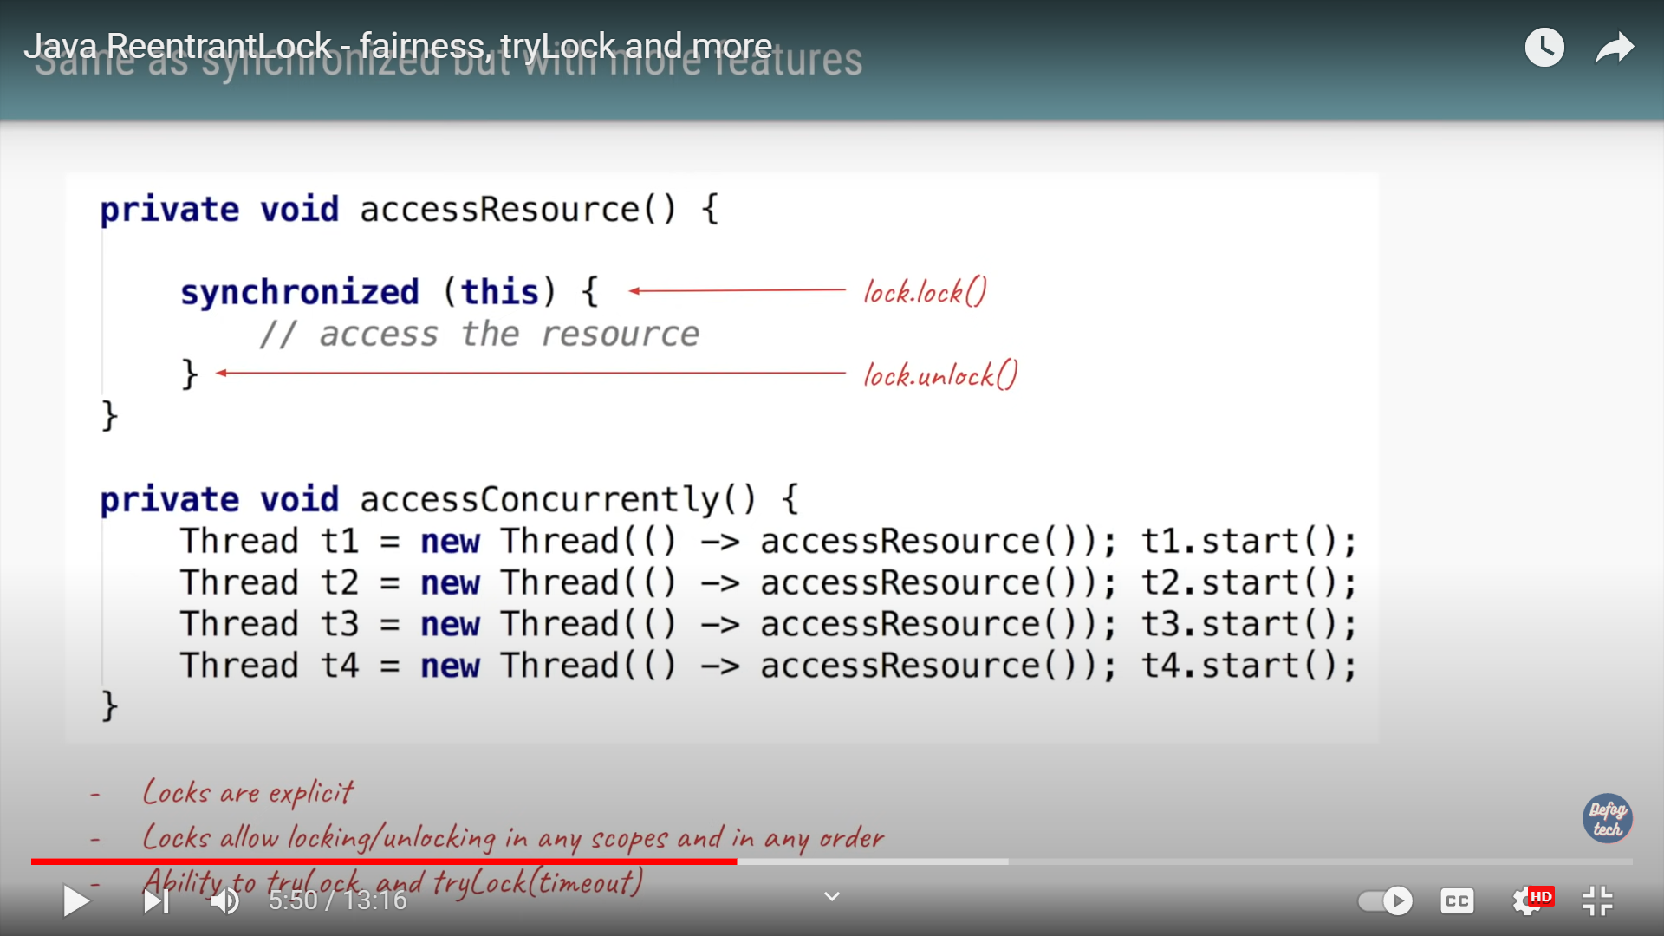

Advantages : read lock , write lock, both.

Concurrency:

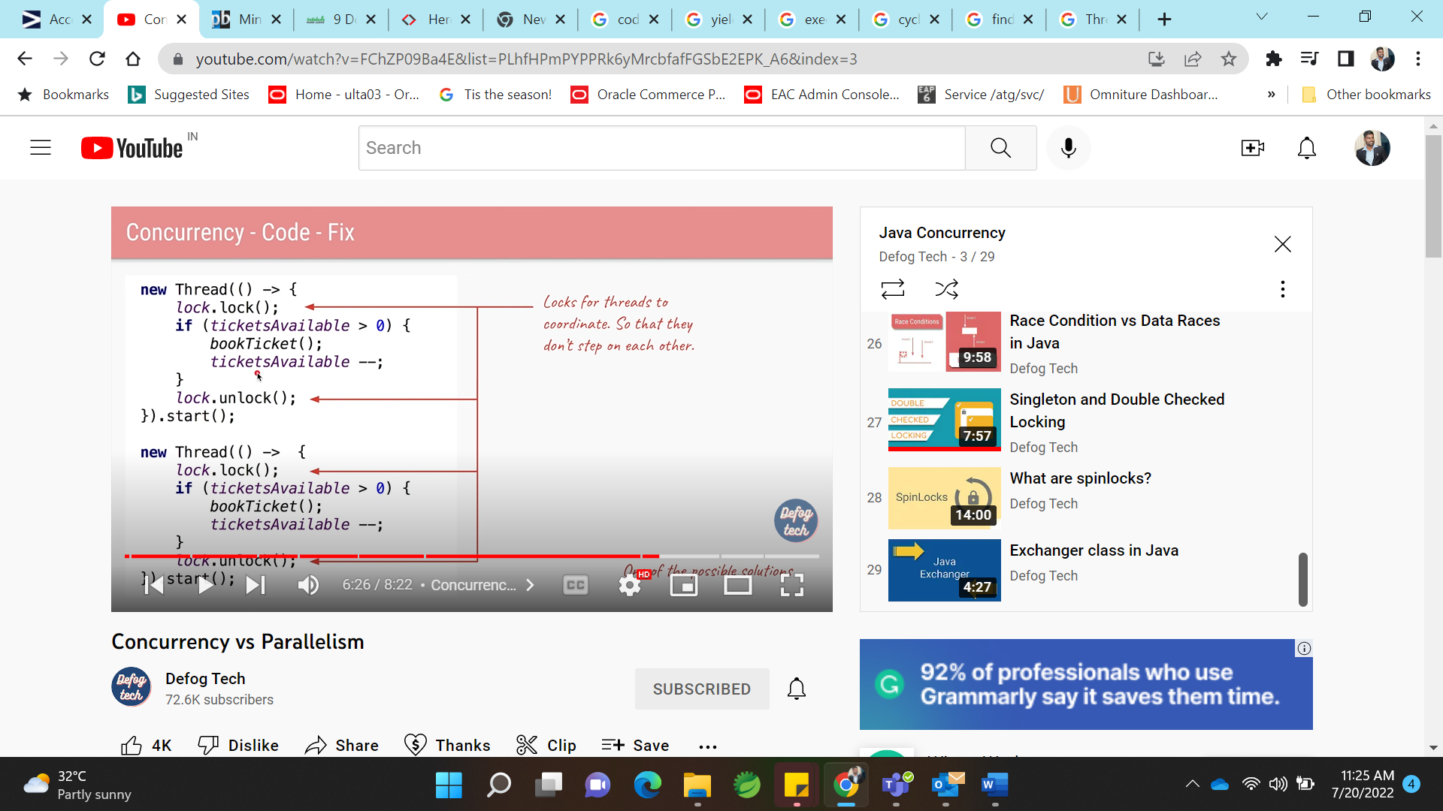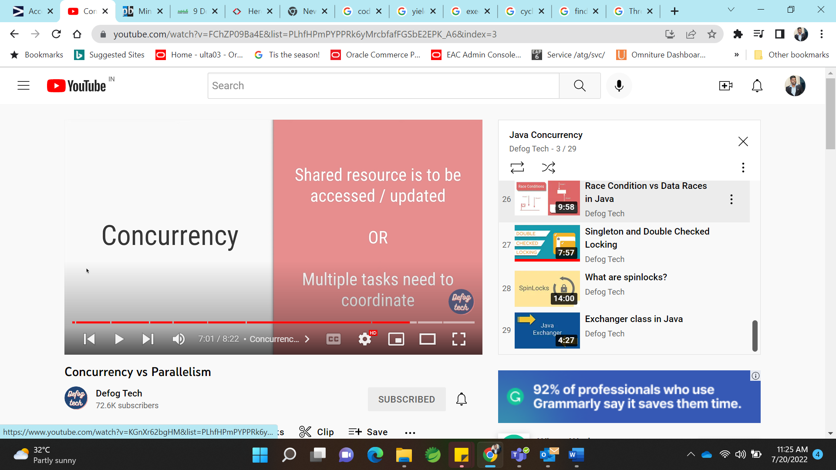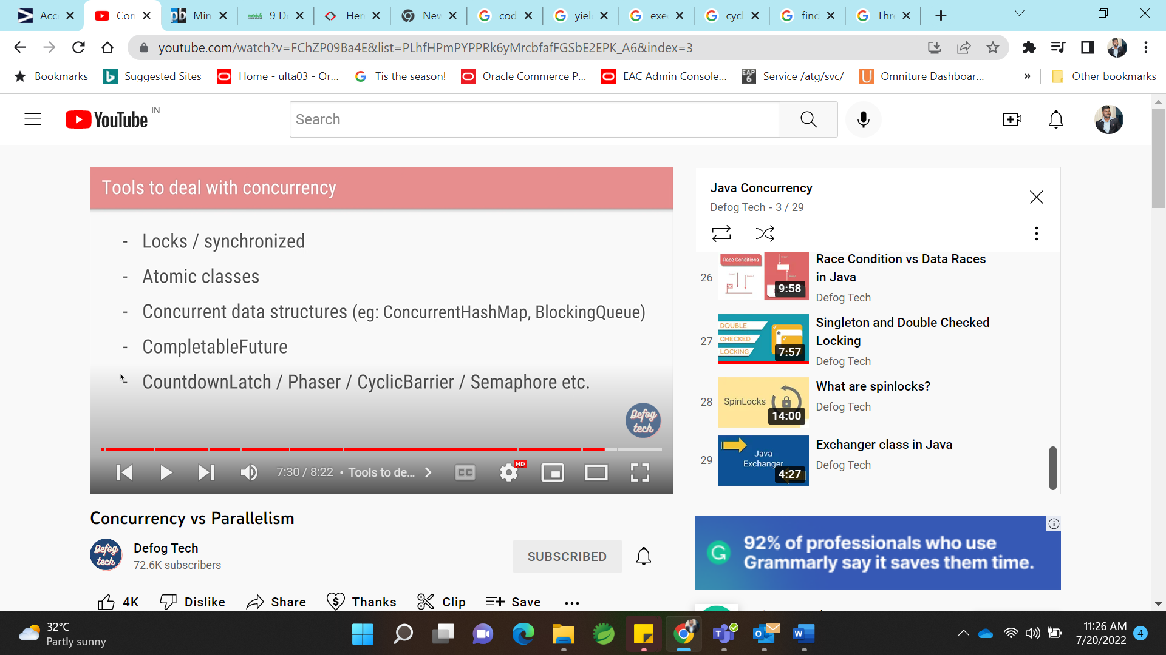 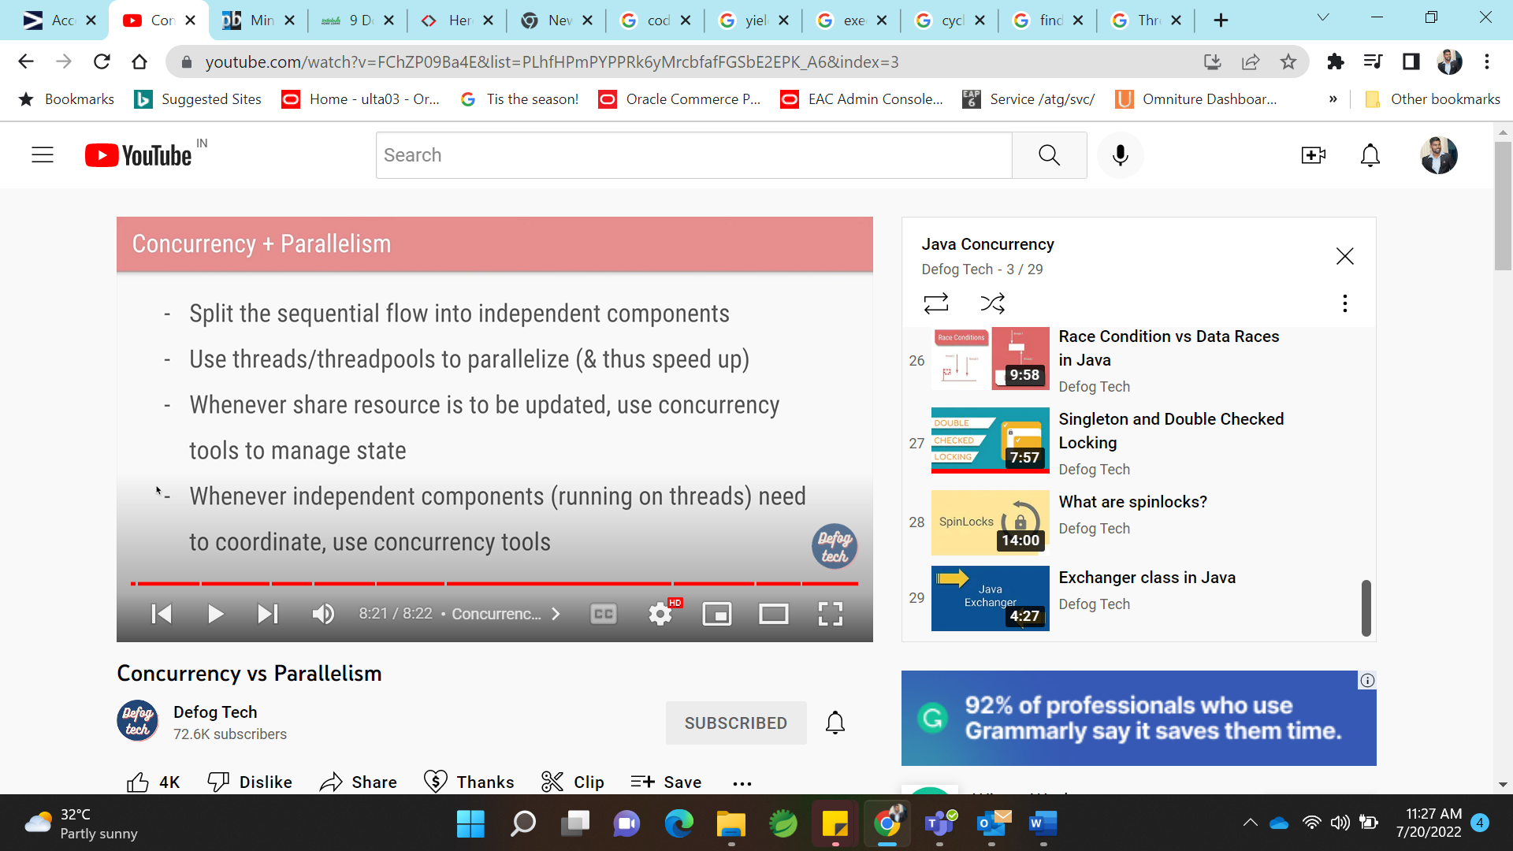

Parellism :

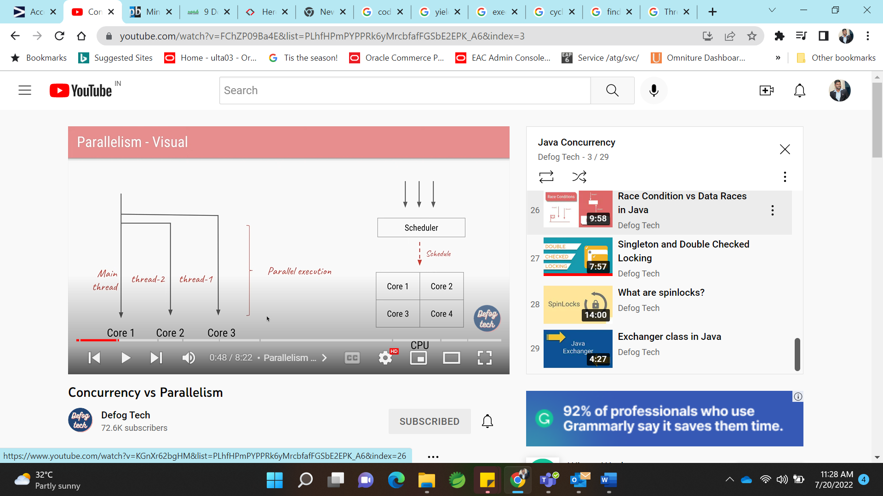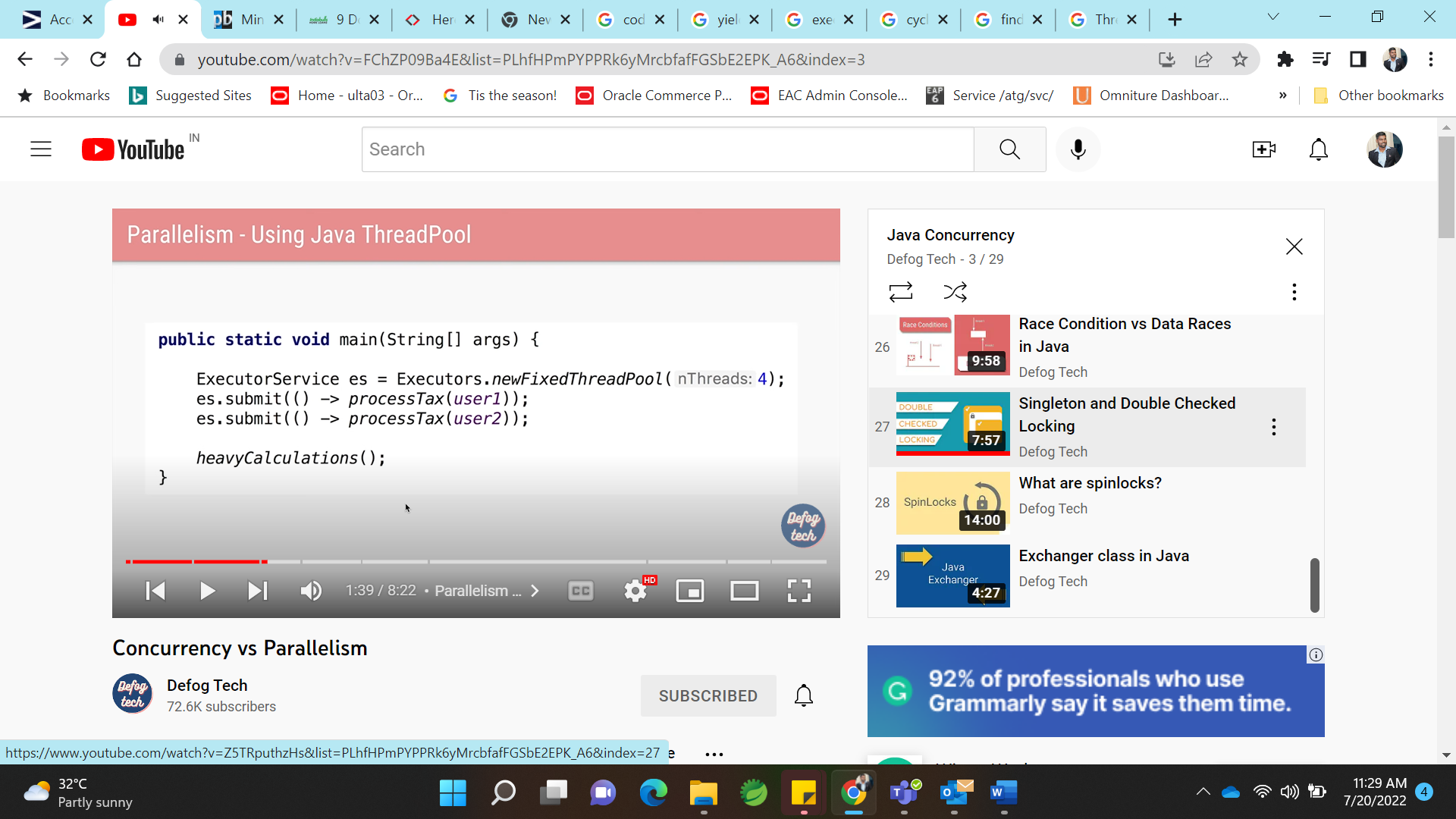

**Countdownlatch**:

Here 3 service are there. Each service is started and initilizated, wait when it reaches countdownlathch. And then main thread start works.

All 3 thread countdown latch, main thread start his operations.

Cyclebarrier:

Lets say we have 3 service, until all these 3 thread reach cycle barrier they all wait and start their operation. For video game, we need to send notification message to 3 players, once initizaltion is done.

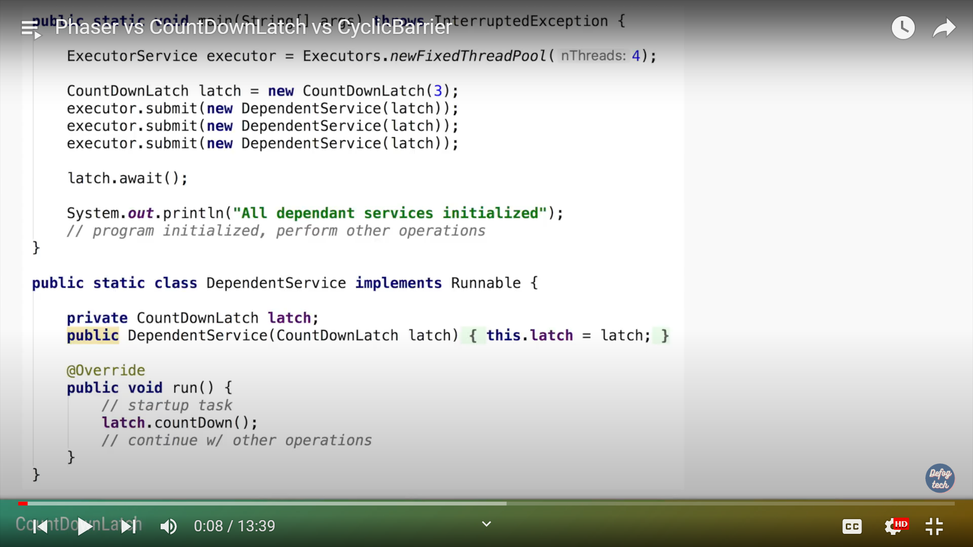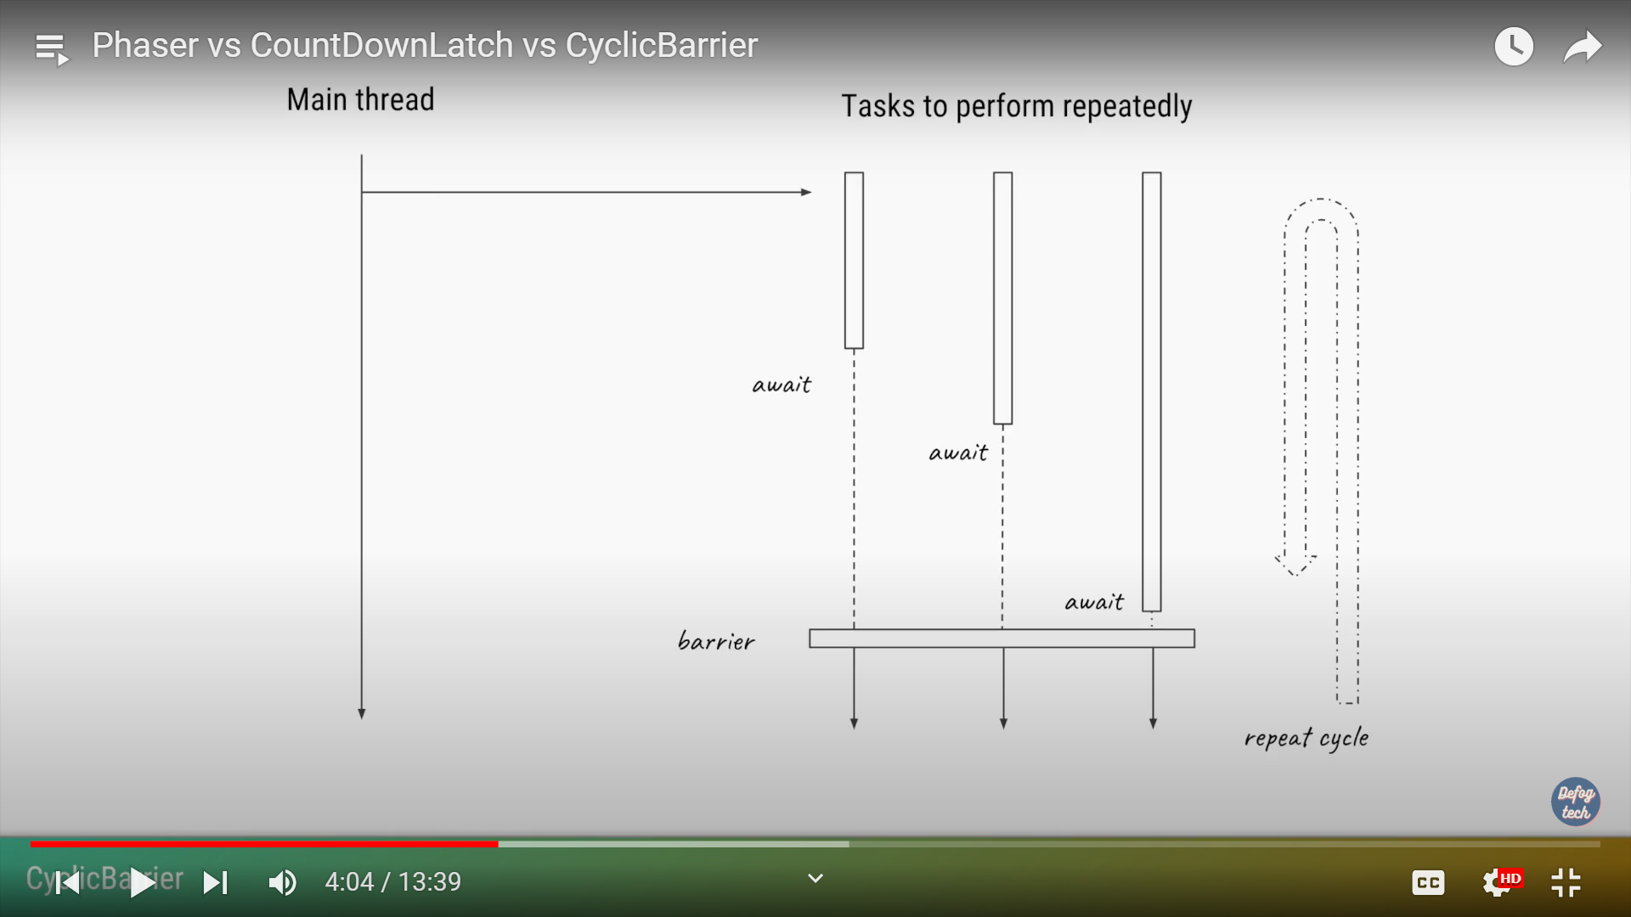



**11) What is a thread local variable in Java?** ([answer](http://javarevisited.blogspot.sg/2012/05/how-to-use-threadlocal-in-java-benefits.html))  
Thread-local variables are variables confined to a thread, its like thread's own copy which is not shared between multiple threads. Java provides a ThreadLocal class to support thread-local variables. It's one of the many ways to achieve thread-safety. Though be careful while using thread local variable in manged environment e.g. with web servers where worker thread out lives any application variable. Any thread local variable which is not removed once its work is done can potentially cause a memory leak in Java application.  
  
  
Read more: <https://javarevisited.blogspot.com/2015/10/133-java-interview-questions-answers-from-last-5-years.html#ixzz7ZZdiZAFo>

### Where to use the wait and sleep method in Java?

By reading the properties and behavior of the wait and sleep method it's clear that the wait() method should be used in conjunction with notify() or notifyAll() method and intended for communication between two threads in Java while Thread.sleep() method is a utility method to introduce short pauses during program or thread execution.

Read more: <https://www.java67.com/2012/08/what-are-difference-between-wait-and.html#ixzz7ZZkUQTjp>

BlockingQueue is a unique collection type that not only store elements but also supports flow control by introducing blocking if either BlockingQueue is full or empty. take() method of BlockingQueue will block if Queue is empty and put() method of BlockingQueue will block if Queue is full.

This property makes BlockingQueue an ideal choice for implementing [Producer consumer design pattern](http://javarevisited.blogspot.sg/2012/02/producer-consumer-design-pattern-with.html) where one thread insert an element into BlockingQueue and another thread consumes it.  
  
In this Java tutorial, we will learn about What is BlockingQueue in Java, How to use BlockingQueue, ArrayBlockingQueue and LinkedBlockingQueue and some important properties of it.

Read more: <https://javarevisited.blogspot.com/2012/12/blocking-queue-in-java-example-ArrayBlockingQueue-LinkedBlockingQueue.html#ixzz7ZaNsPh5a>

**Wait** release lock.. used in synchronization block or method.

**Sleep** don’t release lock, it sleeps some times.